EXPERIMENT 9

VIEWS

**Aim:**

* Create student table(studno, name, dept)
* Display Table
* Create view and select
* insert values
* alter view
* Create view check option
* alter view

**Queries:**

* Create student table(studno, name, dept)

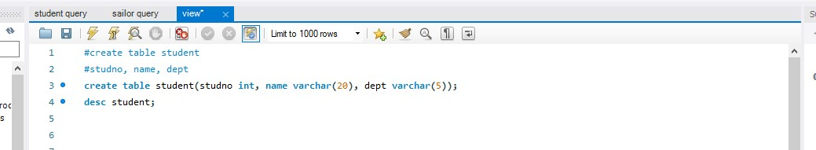

* Display Table

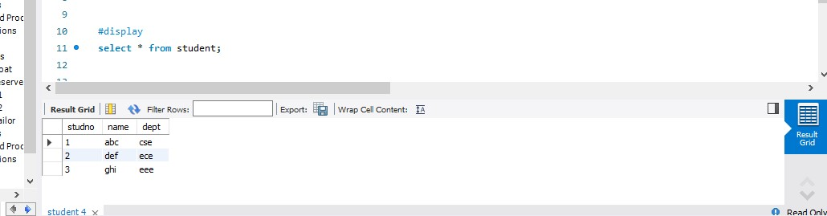

* Create view and select

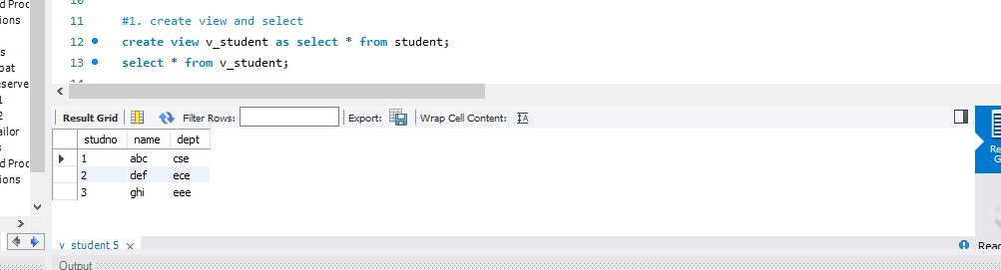

* insert values

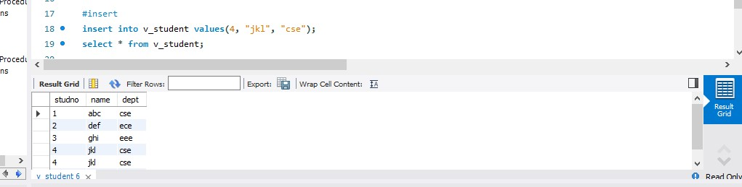

* alter view

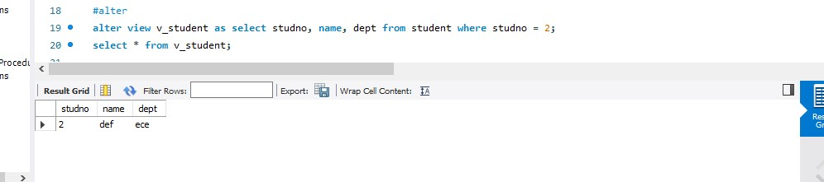

* Create view check option

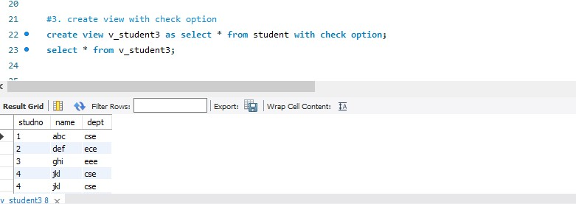

* alter view

